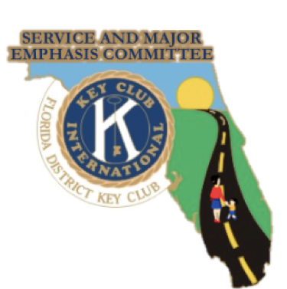

Service Directory
2020-2021

Service and Major Emphasis Committee
service@floridakeyclub.org

Table of Contents

COMMITTEE INTRODUCTION............................1 COMMITTEE INTRODUCTION............................2 GOVERNOR’S PROJECT ...................................3 THIRST PROJECT..................................................4 UNICEF................................................................5 TRICK OR TREAT FOR UNICEF…….....................6 CHILDREN’S MIRACLE NETWORK……..………..7 MARCH OF DIMES .............................................8 DRIVES ................................................................9 WALKS ...............................................................10 KIWANIS FAMILY PROJECTS..............................11 KIWANIS FAMILY PROJECTS..............................12

~Committee Introduction~

Committee Chairs:
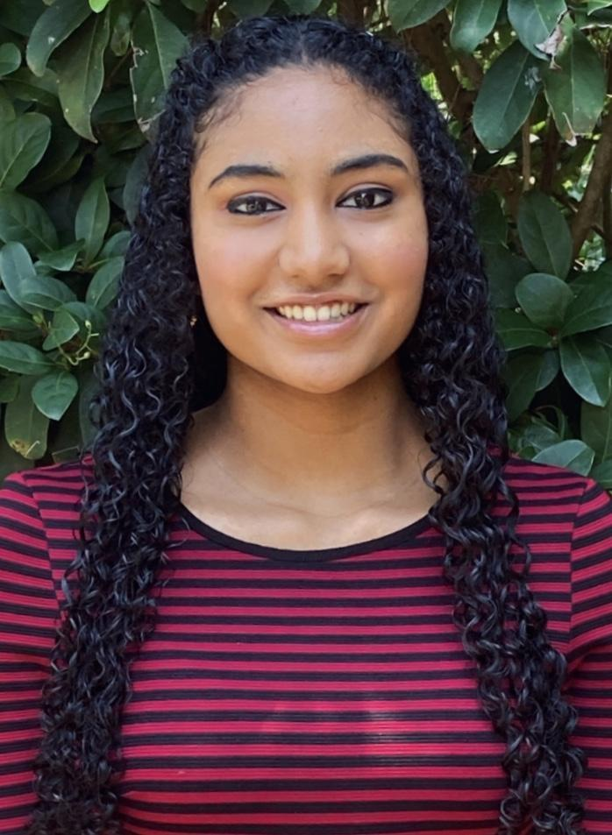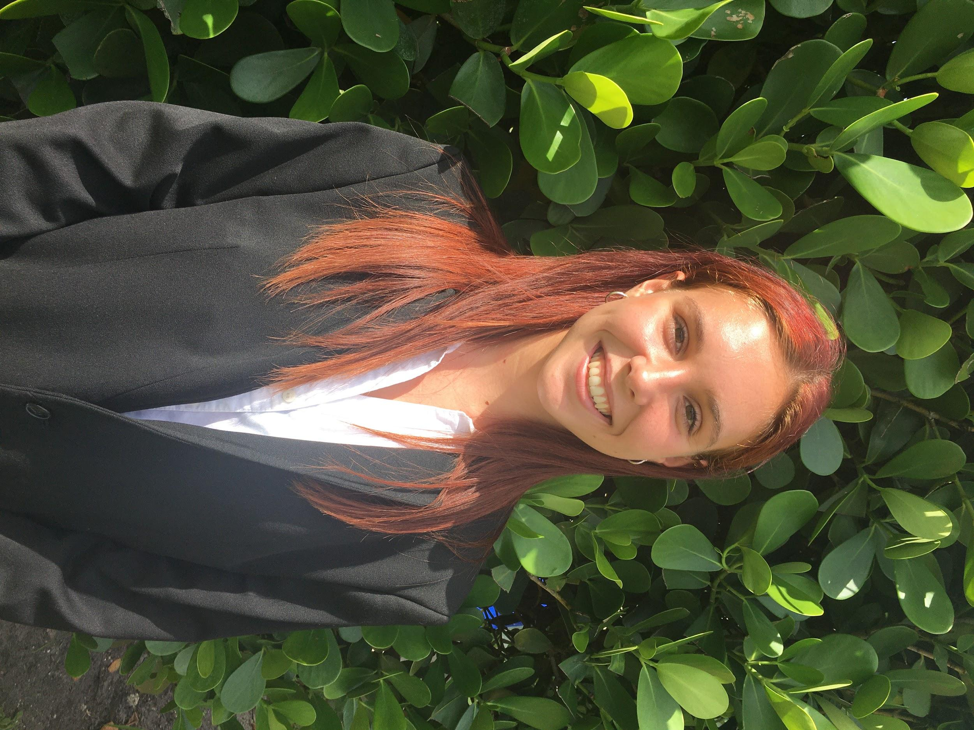
- Division 18 LTG Meera Nair - Division 24B LTG Jenna Kleinman
(division18@floridakeyclub.org) (divison24b@floridakeyclub.org)

Committee Adult Advisors:
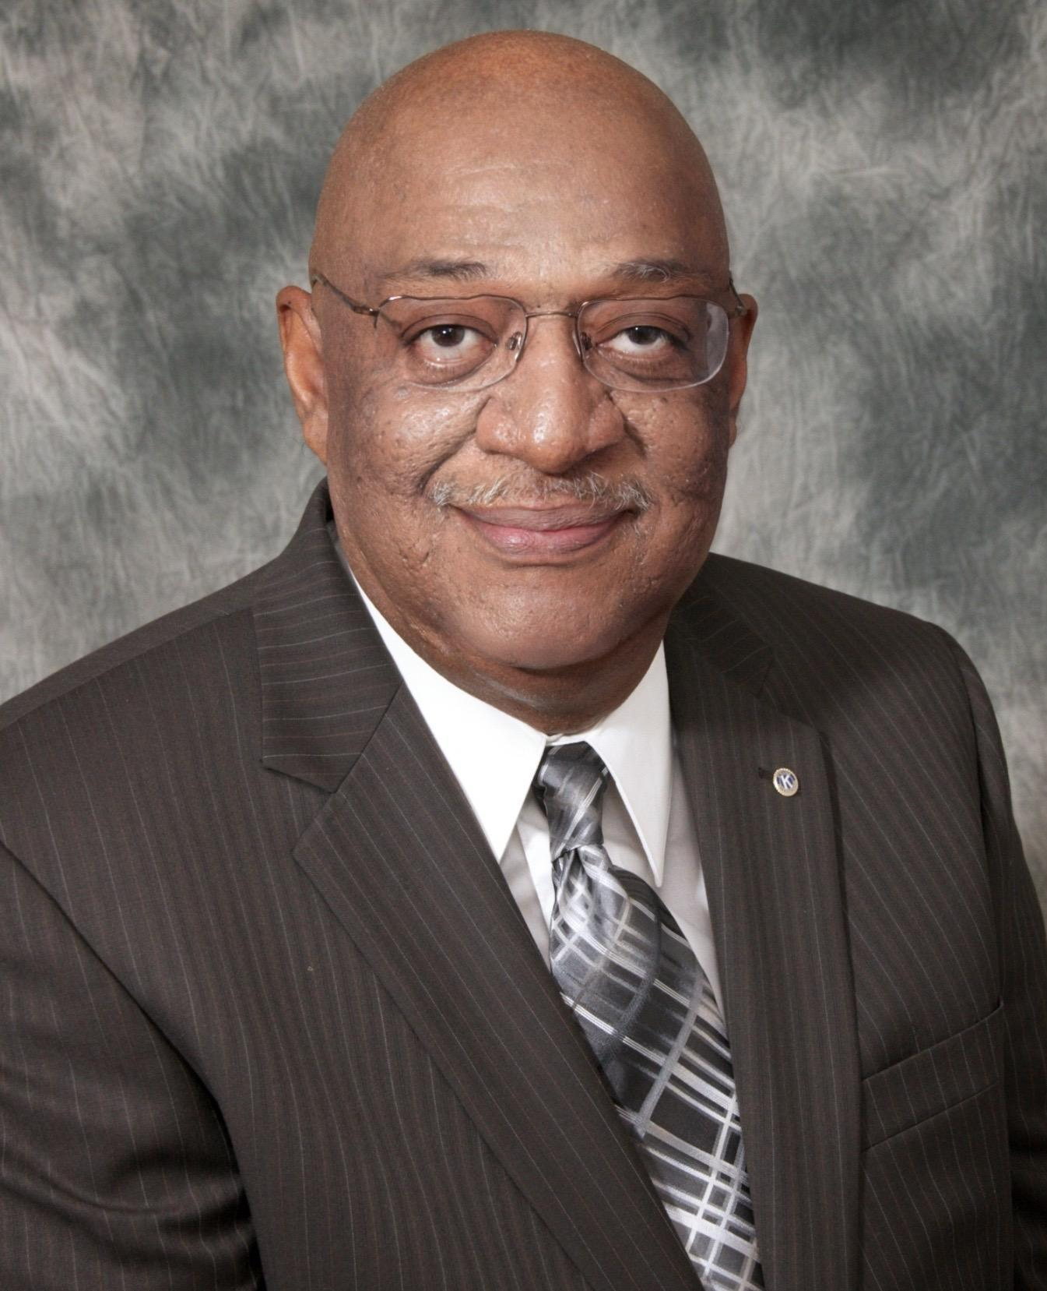
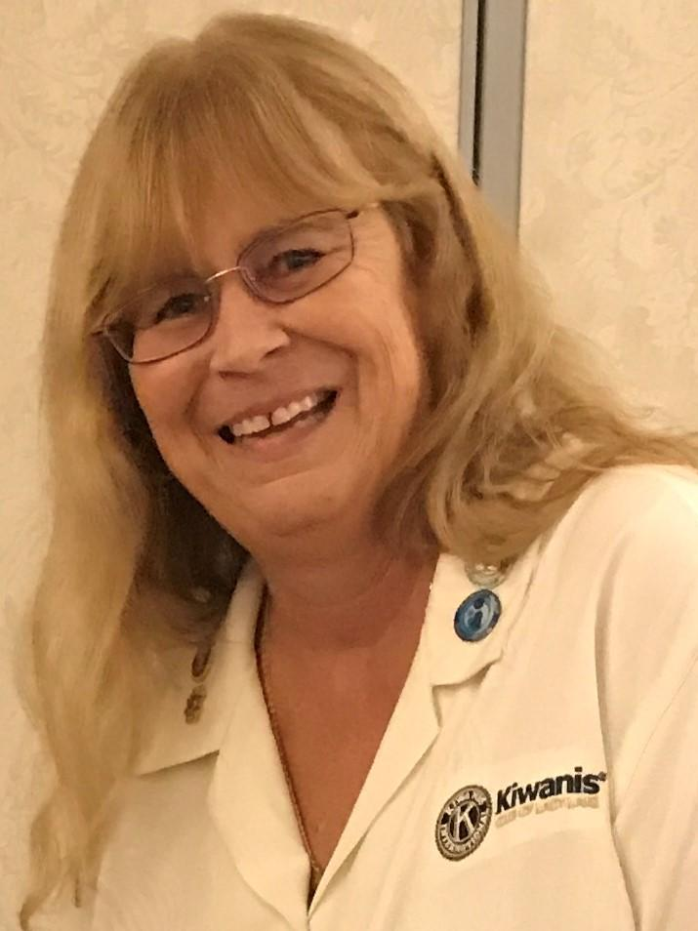
- ZA Cleve Tinsley - ZA Deborah Tinsley
(aazonel@floridakeyclub.org) (aazonel@floridakeyclub.org)

Committee Executive Advisor:

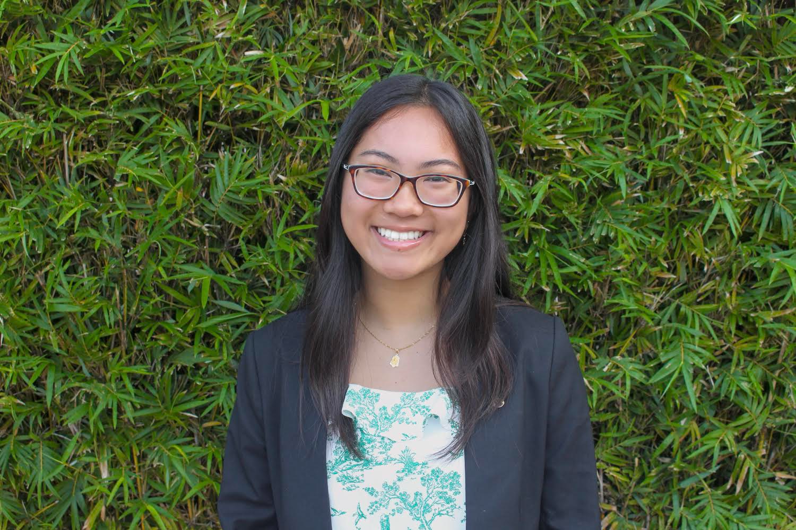
- District Secretary Angela Nguyen
(2021secretary@floridakeyclub.org)

Committee Members:
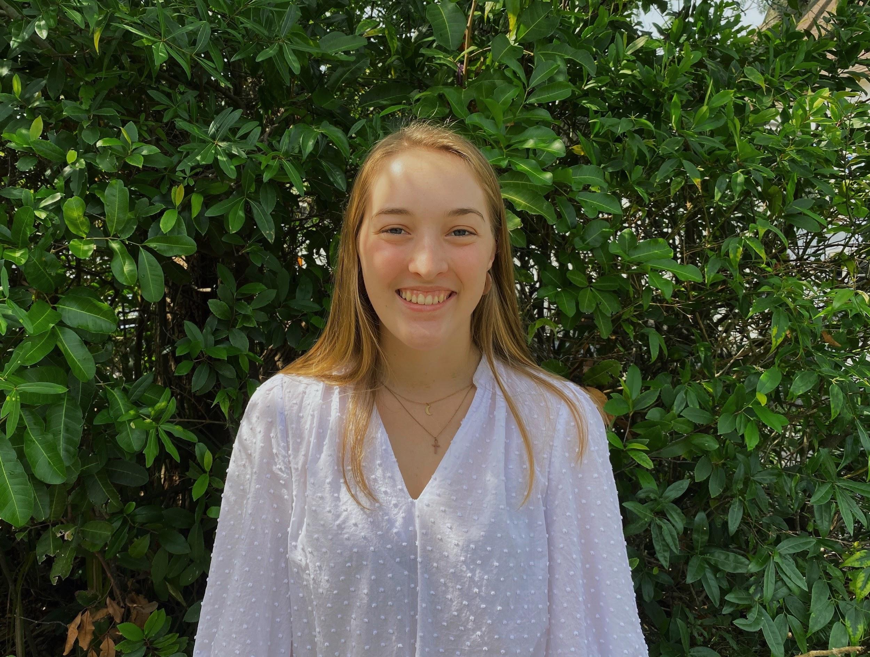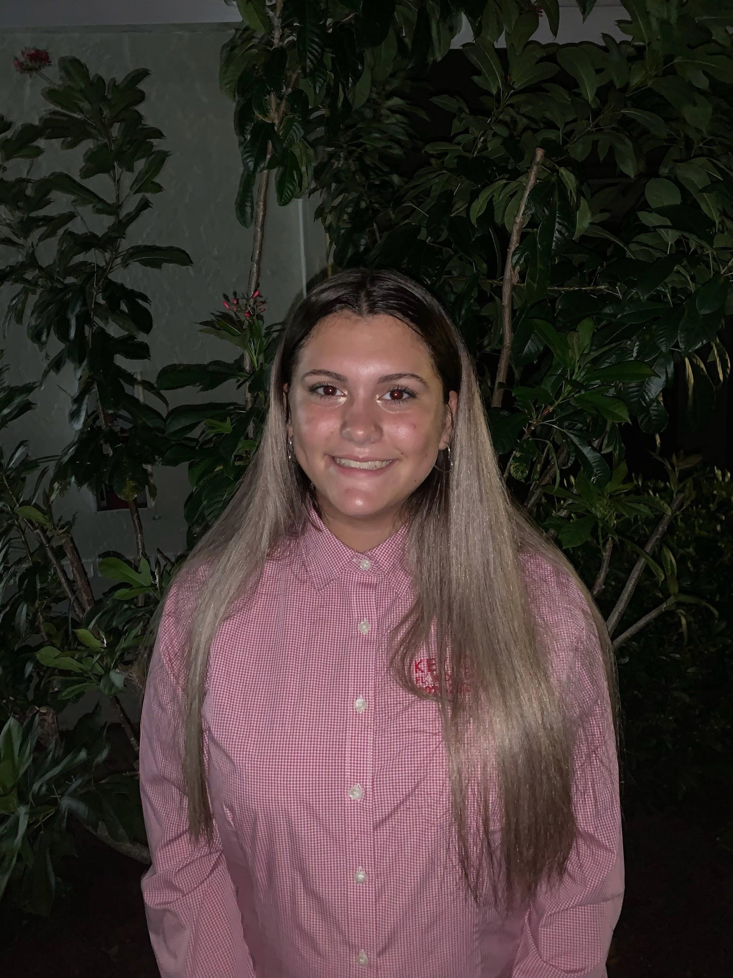
-Division 13 LTG Katelyn Disler -Division 19A LTG Leilani Riesgo (division13@floridakeyclub.org) (division19a@floridakeyclub.org)

~ Committee Note ~

Hello Florida, Cayman Islands, and the Turks and Caicos Key Club District! We are so excited to share with you our Service Directory Booklet for the 2020-21 Key Club year. In this guide, you will find information pertaining to this year’s Governor’s Project, our Major Emphasis partners, and multiple service and fundraising opportunities your clubs can participate in. Please take the time to read through the entirety of this booklet, as it will be a great resource to many of your clubs through this COVID-19 pandemic. Thank you so much, and please don’t hesitate to contact any of us with questions, concerns, or suggestions. Here’s to another great service year, Key Clubbers!

- Yours in Service, Leadership, and Friendship,
The Service and Major Emphasis Committee
(service@floridakeyclub.org)

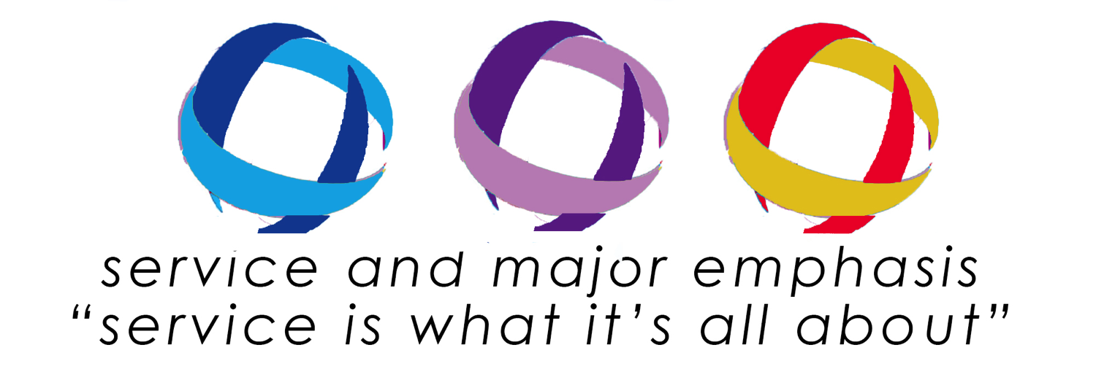

~Governor’s Project~
2020-21 District Governor: Joey Chen
Project Title: KEYS for Kids
Purpose: Unlocking a better future for the younger generation through service!
KEYS: (Kindness to Kids, Empowering Future Leaders, Youth Connections, and Supporting Children in Need)

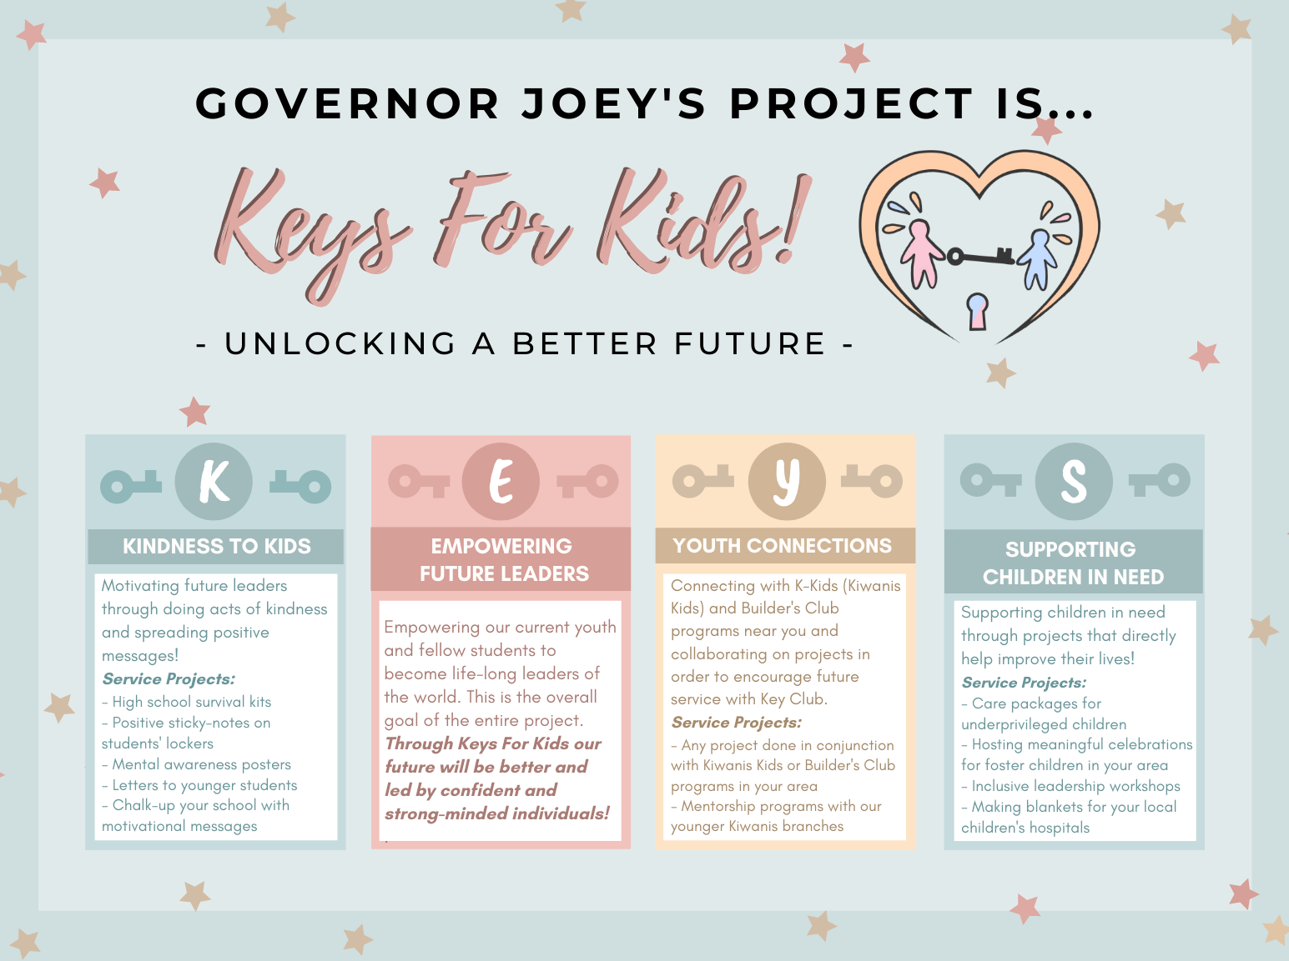

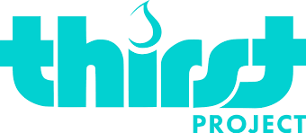
The Thirst Project is the largest youth water activism charity in the world. In just five years, the Thirst Project has worked with developing communities to bring safe, clean water to more than 400,000 people in 13 different countries.
https://www.thirstproject.org/
- - - - - - - - - - - - - - - - - - - - - - - - - - - - - - - - - - - - - - - - - - - -

FUNDRAISE
Plan and execute your own fundraiser event in your school/community to help end the global water crisis! Take whatever you are good at and use it to help give people clean water.
Text “THIRST” to 97779
Click here to start your fundraiser today!

“DIRTY LITTLE SECRET”
Although it is one of the biggest “dirty little secrets” in the world, most people are not talking about the issue of clean water. Carry around a bottle of dirty water with you all month and turn it into a conversation starter. It will give you the perfect opportunity to talk about the global water crisis and what the Thirst Project is doing about it.

WORLD WATER DAY
The Thirst Project encourages everyone to “go silent” on World Water Day, March 22nd, to stand in solidarity with the 780 million whose voices go unheard every day.

RESERVE A SPEAKER
Host an assembly for your entire student body or make a presentation to your club! Email traciemae@thirstproject.org for more info!
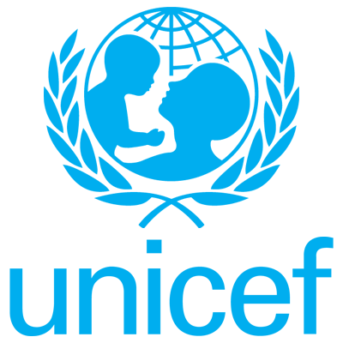
UNICEF and Kiwanis International have joined forces to combat another adversity, maternal and neonatal tetanus (MNT), a deadly disease that steals the lives of 34,000 innocent babies and a significant number of women each year.

By supporting, you can be a hero for millions of children in need. These kids are just like you, except many live in countries where poverty, war or natural disaster make it difficult to get even the basics they need to survive.
https://www.unicefusa.org/
- - - - - - - - - - - - - - - - - - - - - - - - - - - - - - - - - - - - - - - - - - - -

FUNDRAISE
Plan and execute your own fundraiser or event in your school/community!
Click here to start your fundraiser today!
Click here to see fundraisers and events happening near you!

KEY CLUB WEEK
Key Club Week, Nov 2 -6, gives you the opportunity to show your community what Key Club is truly about- service.
Click here for more service ideas and information for UNICEF!
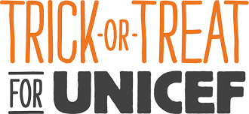

Fundraise throughout the months by either selling pumpkin drops, having donut sales, going door to door, hosting bake sales, or pie in the face fundraisers. On Halloween, trick-or-treat for proceeds instead of candy with UNICEF boxes!
https://www.unicefusa.org/trick-or-treat

All funds raised through the Trick-or-Treat for UNICEF campaign will go towards the Eliminate Project and must be received by December 1st for recognition at DCON.
- - - - - - - - - - - - - - - - - - - - - - - - - - - - - - - - - - - - - - - - - - - -

FLORIDA DISTRICT PLEDGE
In 2015, the Florida District of Key Club pledged to raise $250,000 in 5 years. This year, our goal is to raise $37,251 as a collective district, which means that each division would have to raise an average of $877.41!

ORDER BOXES
Click here for instructions!

MORE INFORMATION
>Go to Floridakeyclub.org
> Club Service and Growth
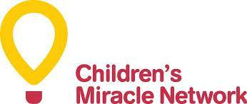

The Children’s Miracle Network (CMN) Hospitals help raise the proper funds and awareness for kids all across the US and Canada. They receive 32 million treatments a year and an average of 62 children enters a CMN hospital every minute.

In fact, 1 out of 10 kids are treated by the CMN. Donations help fund critical treatments, medical equipment, and healthcare services.
https://childrensmiraclenetworkhospitals.org
- - - - - - - - - - - - - - - - - - - - - - - - - - - - - - - - - - - - - - - - - - - -

DONATE
Since 1983 CMN has filled more than $5 billion funding gaps.
You can donate online or by check.
Click here to donate today!

HOW TO HELP
https://childrensmiraclenetworkhospitals.org/how-to-help/#fundraiser
Click the link and start your own fundraiser!

March of Dimes supports mothers throughout their pregnancy, advocate for policies that prioritize their health, supports radical improvements to the care they receive, and pioneers research to find solutions to the biggest health threats to moms and babies.
https://www.marchofdimes.org/index.aspx

- - - - - - - - - - - - - - - - - - - - - - - - - - - - - - - - - - - - - - - - - - - -

GET INVOLVED
You can volunteer for March of Dimes, create your own event, or host a community walk.
For more information about these, click here!

FUNDRAISE
Plan and execute your own fundraiser or event in your school/community!
Click here to start your fundraiser today!

DONATE
Help advocate for better conditions for pregnant mothers. Donations can be done online or by check.
Click here to donate today!

~Drives~

MEALS ON WHEELS
http://www.mealsonwheelsamerica.org/
Meals on Wheels helps provide meals to people in need. You can help Meals on Wheels by holding canned food drives at your school or by volunteering at a local Meals on Wheels location.

BECCA’S CLOSET
http://www.beccascloset.org/
This is an organization to help students who cannot afford having either prom or homecoming dresses. This closet has expanded to other forms of clothing such as jeans,and business attire Other items could be jeans, but they should be lightly used. Hold a clothing drive at your school (you will need ten plus workers and a place for clothes). Having a distributing day will help with the success of the project.

SAT/ACT BOOK DRIVE
https://www.dosomething.org/campaigns/sat-book-donation
This drive is to help low income students with SAT/ACT books so each student has an opportunity to succeed!

SOUPER BOWL
https://souperbowl.org/
The basic goal of the project is to collect and donate as many cans of food as possible to local homeless shelters or any organization that collects cans. Donating canned food items to Souper Bowl of Caring helps ensure that homeless people are fed.

SALVATION ARMY
http://www.salvationarmy.org/
This is an international organization that focuses on bettering the lives of others through collecting clothes and assisting homeless throughout the world.

~Walks~

RELAY FOR LIFE
Relay for Life offers everyone in the community an opportunity to participate in the fight against cancer. Teams of people camp out at a local high school

ALZHEIMER’S MEMORY WALK
Since 1989, they’ve mobilized millions of Americans in the Alzheimer’s Association Memory Walks. They now ask you to register for Walk to End Alzheimer’s, the nation’s largest event to raise awareness and funds for Alzheimer’s care, support and research. Together, we can end Alzheimer’s disease, the nation’s sixth leading cause of death.

MICHAEL J. FOX FOUNDATION FOR PARKINSON’S RESEARCH
Host a walk to help find a cure for Parkinson's disease. The proceeds will go towards research for Parkinson’s disease. The Michael J Fox Foundation is a nonprofit, tax exempt organization.

HEART WALK
This is The American Heart Association’s lead fundraiser aimed towards raising funds for heart disease and stroke. It also focuses on healthier lifestyles.

WOMEN FOR WOMEN
Women for Women International provides women survivors of war, civil strife and other conflicts with the tools and resources to move from crisis and teach twenty useful skills. You can help by organizing a Run for Congo Women walk and raise money to donate it.

~Kiwanis Family Projects~

KIWANIS KIDS
K-Kids is the youngest branch of the K-Family. They talk on the responsibility of running a K-Kids club as they participate and plan different types of service projects, whether it be assisting the elderly with chores or arranging a community food drive. It is great to team up with a Kiwanis Club near you. If you do not have one in your area, speak with your Kiwanis Club about chartering one.

BUILDER’S CLUB
Builder’s Club is the middle school version of Key Club. They plan and participate in service projects and learn to be great leaders. If you do not have one in your area, speak with your Kiwanis Club about chartering one. It is a great opportunity to partner with Builders Club at events and meetings.

AKTION CLUB
Aktion Club is the one service club for adults that have disabilities. They participate and plan projects similar to Key Cub. If you have an Aktion Club in your area, team up!

CIRCLE K INTERNATIONAL
CKI is the collegiate branch of the Kiwanis Family. This branch in particular has the highest number of service hours per member ratio in the Kiwanis Family. Find a CKI in your area and team up with them on service projects.

KIWANIS FAMILY RELATIONS
Kiwanis One Day is one day of the year when Kiwanis clubs around the world participate in one day of service. This year, Kiwanis One Day will be observed on October 24th.

KIWANIS YOUNG CHILDREN PRIORITY ONE
YCPO focuses on the needs of younger children in need in their areas and then bases service projects on the children’s specific needs. By teaming up with YCPO, you not only help strengthen your K-Family bonds, but you also help local children in your community.

EVERY CHILD A SWIMMER
Every Child A Swimmer is to teach children how to swim, and water safety procedures. K-Family can participate in ECAS by being “in water assistants” to the trained professionals teaching the children to swim.

