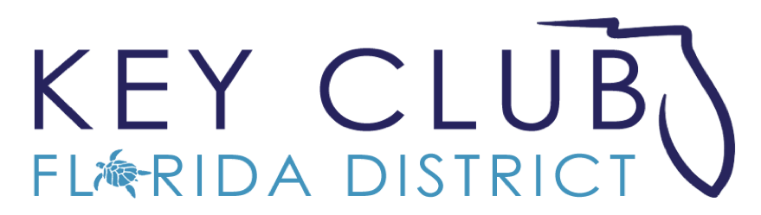
Service Hour Guide

Florida District of Key Club International Inc.
2020-2021

TABLE OF CONTENTS
Definition of a Service Hour 1
Tracking Service Hours 3
Service Hour Form 4
Importance of Reporting _____________________5
A Message From the Committee 6

Definition of a Service Hour
Key Club International Guidebook
“A service-hour constitutes any hour of service performed by an individual Key Club member with the approval of his/her club’s board of directors.”
(Key Club International Guidebook/Section 2. Key Club International Board Policies, F. Club Structure and Activities, 7. Definition of a Service Hour)
This is what constitutes a service hour:
- Projects pre-approved or organized by the individual Key Club
- Any project that improves the community
- Book drives, food drives or any other drive benefitting others (the service hour is the actual time worked to collect, count, package, and/or deliver the objects. Hours are not given based on items provided)
- Serving as a host club at the District Education and Leadership Conference or Key Club International
- Conventions / conferences (actual time worked, not time spent attending these events)
- The time spent in planning a project will be counted as a reportable service hour
- The time spent participating in service projects held at Divisional, District, and International events
When reporting hours on Pride Reports or award applications, only hours earned from Key Club approved projects and worked by dues- paid members of that Key Club can be recorded. No outside volunteers can count towards these hours.

1

Definition of a Service Hour Continued
This is what does not constitute as a service hour:
- Attendance at DCMs, KCKCs, Zone Rallies, DCON, and ICON (Exception: time spent doing a service project at these events)
- Club, Board, committee or other non-service planning or meetings
- Any Kiwanis Family meetings where project planning was not its purpose
- Socials, parties, dances, or church services
- Fundraisers for the individual Key Club’s own use, such as, but not limited to, raising money to have an end of the year banquet or to attend DCON or - ICON)
- Time spent not working during overnight service projects such as but not limited to, eating and sleeping
- Providing transportation for members and time spent going to and from a service project
- Paid and unpaid internships
- Any time in which a member is paid for his or her services (unless the payment is to the club to be used in community service
Special Attention is given to a common phenomenon seen recently throughout the District of awarding hours for tasks that do not require actual service. This relates to activities such as canned food drives and toy drives. Each separate item brought in should not be treated as a separate service hour as it does not require that any actual service be performed. Clubs should review their policies regarding these types of events and make special determinations of how these types of actions should be recorded for individual purposes.
It is also very important that, as our service year progresses, clubs and their members should refrain from tasks that involve individuals “buying” their hours. Afterall, this is a service organization and it is important that our members are out there in their communities performing actual service.
NOTE: Clubs may award additional hours for incentive purposes or purposes for their own records, however, they must not be reported to the District as Key Club service hours. Such incentives could include a point-based system for members. Reference the Point System Booklet for more information on how you can implement one in your club.
2

Tracking Service Hours
Members:
Have individual members keep track of their own hours by utilizing a service log for each year. Getting the advisor’s confirmation and signature on each hour log may help show proof of community service hours when applying for scholarships or filling out forms.

Club Secretary:
Secretaries should fill out monthly report forms as accurately as possible so that members can rely on those documents as needed. Hour logs from the previous year should be archived so they provide a resource in future years.

Club Class Directors:
Directors should fill out monthly report forms as accurately as possible so that members of their class can rely on those documents as needed. Hour logs from the previous year should be archived so they provide a resource in future years.
3

Service Hour Form
Name:
Student ID:
Member ID:

Date | Time Worked | Event Name | Hours

Club Advisor Signature:
4

Importance of Reporting Hours
It is extremely important that, as a club, hours are being reported accurately and effectively. To do this, secretaries, specifically, should reporting their club members’ data to the OPR System through their Pride Reports.
Reporting your club hours can help make sure you have a chance for a service award at DCON, it helps to showcase the awesome work you’ve been doing around your community and can help you keep track of your club’s progress throughout the year.
Your club’s hours can be counted towards the Governor’s Project or one of our many Major Emphasis Projects and show our District just how much you care about our partner organizations.

5

Leaders of the Florida District,
I hope this booklet will be a big help to your club! Keeping track of service hours will provide many benefits in the future. Accurate recordings will allow you to receive recognition, contribute to district goals and see improvements in your home club from year to year. You will also know how many hours you have, helping you to apply for scholarships and other incentives. We hope that you have learned more about service hours and it is our hope that this guide will help you succeed in accurately tracking hours. If you have any questions or concerns, feel free to reach out to the Service and Major Emphasis Committee.
Our committee is committed to helping servant leaders be successful in all that they do. We advocate for meaningful and impactful service throughout the Florida District with emphasis on increasing district involvement with Key Club associated charities. Additionally, we work together to provide ideas, training, and motivation regarding service project planning and implementation. We aim to serve as a resource for other Lieutenant Governors and individual clubs throughout the Mighty Florida District.
Please make sure to send all of your favorite projects to our wonderful Executive Assistant Arianna Longo with photos and descriptions at 2021executiveassistant@floridakeyclub.org!
Committee Contact Information
service@floridaykeyclub.org
Chairs Contact Information
Meera Nair: division18@floridakeyclub.org
6
Jenna Kleinman: division24b@floridakeyclub.org

