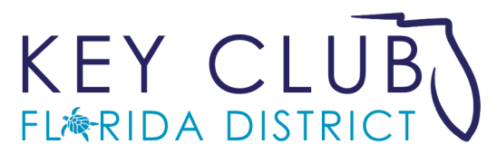
District Education and Leadership Conference
Program Advertisement Form

Deadline for Ads: Must be received by March 1, 2017
Dear Advertiser,

The Florida District of Key Club is asking for your financial support through the purchase of program advertisement for its 79th annual District Education and Leadership Conference March 30 – April 2, 2017 in Orlando, Florida. Distributed to all 2,100 teenagers and adults in attendance, our conference program book will give you wide exposure while helping to make this year’s educational conference a success. Please visit www.floridakeyclub.org/dcon for more information on our conference.

The Florida District of Key Club International, Inc. provides leadership education to its members which prepares them to become service leaders. Key Club is a program of Kiwanis International, an adult service organization whose focus is on serving the children of the world.

For the Key Club:

Ad Size (Full color) | Cost
Full Page 5.5w x 8.5h | $175
Half Page 5.5w x 4.25h | $125
Inside Back Page | $500
Inside Front Page | $500
Outside Back Cover | $750
Each club is encouraged to sell at least $150 in ads. Funds in excess of program printing costs will fund college scholarships for graduating members. Key Club graduates of clubs that sell at least $150 in advertisements will be eligible to apply. Applications are available at www.floridakeyclub.org/scholarships.
For the Advertiser:
The undersigned advertiser encloses payment for an advertisement to be placed in the Florida District of Key Club’s Annual District Conference program book as noted.
Advertiser Information: This may be completed online. See “Online” information below.

Name:  Street:  City:  State, Zip Code:  Contact Phone:  Email Address:  Key Club to credit (if known):  Key Club Division (if known): | PAYMENT (or may be made online – See below):  Ad size: Quantity: Total: $  Payment method (check only one)  eCheck – Required for this option:  Routing number:  Account number:  Check Visa MasterCard Discover  Card Number:  Expiration Date: / Security Code  Signature (type name):

Payment & Submission:

By mail or email: The form and ad copy may be emailed to DCONAd@floridakeyclub.org or mailed to Florida Key Club, 5545 Benchmark Lane, Sanford Florida 32773. Provide credit card information above or pay by check to Florida District of Key Club. If paying by check, mail to above address.

Online: Payment and form submission may be securely completed at https://secure.qgiv.com/for/fkcac. The above information will be requested at that site.

For questions or more information contact:
District Conference Chair Hannah Rosenbaum at dconchair@floridakeyclub.org or
Conference Administrator David McCampbell at adadavid@floridakeyclub.org.

The Florida District of Key Club International, Inc. is a U.S. tax-exempt 501(c)(3) organization. Donations are tax deductible.

